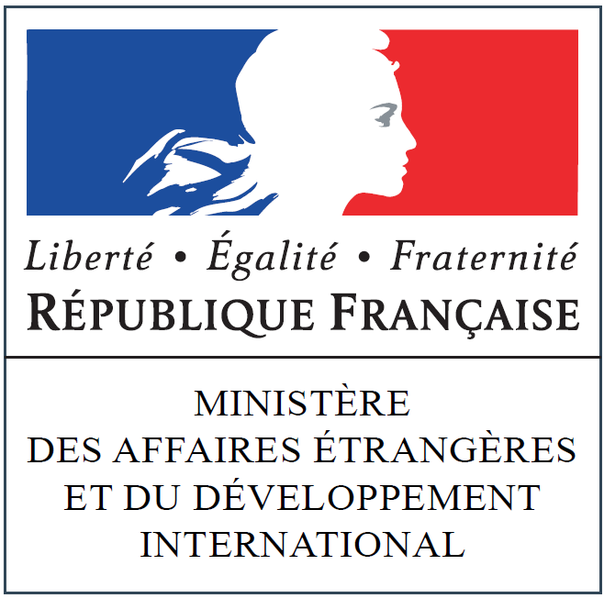 | 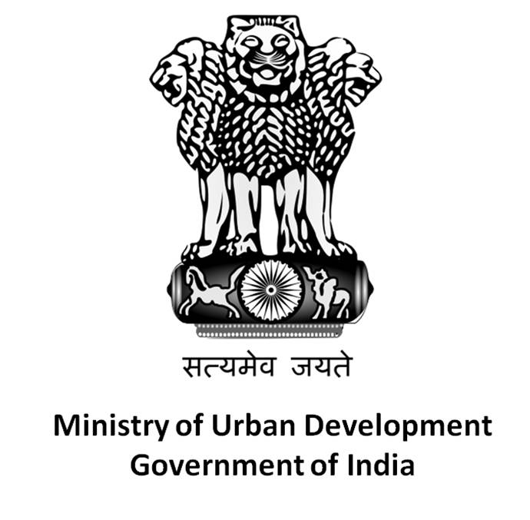 | 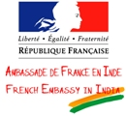

2nd Call for Joint Indo-French Projects
in Support of Decentralised Cooperation
2014-2015

Considering the First Indo-French Seminars on Decentralised Cooperation, held from 15 to 17 January 2010 in New Delhi, India, the goal of which was to assess the prospects of possible cooperation between local government authorities of the two countries and in which more than 30 French and as many Indian local government authorities had participated,

Considering that this forum had enabled the participants to acquire mutual knowledge of the territorial organisation of the two countries, one federal and the other unitary, and that it had facilitated the identification of common sets of problems in different contexts in a globalised world,

Considering the shared will of the governments of India and France to encourage the development of cooperation between French local government authorities on the one hand, and the Indian states and urban local bodies on the other,

Considering the Joint Statement by France and India marking the visit of the President of the French Republic in February 2013, committing the two countries to promote enhanced cooperation in the area of sustainable urban development, in particular as regards infrastructure, transport, water, waste management and urban development,

Considering the 11th meeting of the Indo French joint working group on urban development in September 2013 under the Ministry of Urban Development (MoUD) and the Ministry of Regional Equality and Housing, Ministry of Ecology, Sustainable Development and Energy (METL-MEDDE), as part of the intergovernmental agreement of 5 October 2012, signed between France and India in the field of sustainable urban development, and which brought local governments together to prepare an annual action programme,

To attain the abovementioned goals, the French Ministry of Foreign Affairs and International Development (MAEDI) has decided, in collaboration with the Indian authorities, to launch a second call for joint projects supporting decentralised cooperation between France and India.

The call for joint projects is open to all French and Indian local government authorities, from 1 March to 15 August 2014.

In this context, the MAEDI will provide financial assistance to Indo-French decentralised cooperation projects. The grant of aid to projects will depend on the commitment of the partner Indian local government authority to co-finance the projects.

French local government authorities are requested to contact the Departments of the Embassy of France in India, which will be their privileged interlocutors for further information on the local context of the envisaged cooperation.

- Eligibility criteria

The projects must be presented by at least one French local government authority associated with at least one State or Indian local authority. Projects may also be presented by groups or associations of local authorities.

The projects must be jointly drafted, in French as well as English, by the French and Indian local government authorities (support letters and letters of intent from the competent local authorities of the two countries must be attached).

The priority cooperation themes for this call for projects are:

- Sustainable Urban development (urban planning, operational urbanism, urban governance, local public services, transport, water supply, sanitation, waste management);
- Economic development;
- Culture;
- Heritage;
- Tourism and eco-tourism;
- Education and training;
- Higher education;
- Public Health;
- Institutional support and capacity building.

In the abovementioned key areas, project proposals can cover concrete cooperation projects or any action aiming at sharing experience and skills, led by one or several French local government authorities with one or several Indian local authorities.

Priority will be given to projects which also include gender and development objectives, projects to improve gender equality and which set gender performance indicators.

These could either be bilateral cooperation projects or common projects focusing on the abovementioned themes, as well as any action aiming at resource pooling and resources capitalisation in keeping with the key themes above.

- Contribution of local government authorities

From the French side, the contribution shall be equal to a maximum of 50% of the total project financing cost:

- Applications from a single local government authority shall be eligible for MAEDI grants up to a maximum of 25% of the total project cost. This ceiling could be raised to 35% in case of projects jointly carried out by several French local authorities or for new decentralised cooperation projects. The maximum contribution of the MAEDI is fixed at 30,000 euros per project.

- In-kind contributions of the French local government authorities shall be taken into account to determine the MAEDI’s financial support up to a maximum limit of 30% of their global contribution.

The Indian side, for its part, shall provide financing at least equal to that of the French one, i.e., 50% of the total project financing cost, which could include a cash contribution and duly quantified in-kind contribution.

- Duration of projects

The duration of projects shall not exceed 12 to 24 months. A final technical and financial execution report shall be submitted at the end of the project, at the latest by 30 June 2016. For the French side, the report shall be sent to the Embassy of France and the Delegation for the External Action of Local Government of the MAEDI.

- Application Procedure

The application file shall include the following :
- The project presentation and description form (filled and signed by the French and Indian project leaders) as well as the relevant attachments;
- Letters of intent from the partner local government authorities and local authorities, indicating the co-financing amount applied for.

Project applications shall be made exclusively in digital format to the following address: www.diplomatie.gouv.fr/cncd, in both French and English versions.

The project presentation and description form can be downloaded in both French and English versions from 1 March 2014 on the following websites:

- website of the Delegation for the External Action of Local Government of the MAEDI (www.diplomatie.gouv.fr/cncd);
- website of the Service for Cooperation and Cultural Action at the Embassy of France in India (www.ambafrance-in.org);
- website of the Ministry of Urban Development, Government of India, moud.gov.in.

An acknowledgement of receipt shall be sent to the applying French local government authorities.

- Project selection

The projects will be scrutinised in France and India during a meeting of the Selection Committee, which will be composed of:
- in France, representatives of the Embassy of India in Paris and the Delegation for the External Action of Local Government of the MAEDI;
- in India, representatives of the Embassy of France in India, the Ministry of External Affairs, the Ministry of Urban Development.

Additionally, the French side of the committee will seek the advice of the regional prefectures and the services of the Directorate-General of Global Affairs, Development and Partnerships, MAEDI, as well as that of the Asia and Oceania Directorate and the relevant line ministries.

The results of the selection will be notified to each leading local government authority having submitted a project, at the latest by 1 October 2014.

- Final project execution and assessment report

The submission of the final project execution and assessment report is mandatory and should be tendered at the latest by 30 June 2016.

The project execution and assessment report shall include the technical aspects of the project in the first part and its financial aspects in the second part.

Particular attention shall be paid to the analysis of the project’s impact and the durability of its results.

The final execution report signed by the competent authority shall be submitted via the dedicated section of the CNCD website (http://www.cncd.fr) set up by the leading French local government authority. An e-mail will then be sent automatically to the Delegation for the External Action of Local Government (DAECT), the Regional Prefecture (General Affairs Secretariat) and the French Embassy.

- Schedule

Deadline for receiving applications: 15 August 2014.

Results of the file processing and notification: at the latest by 1 October 2014.

Deadline for the submission of the final technical and financial execution report: 30 June 2016.

- Contacts

Embassy of France in India: Laurent Defrance, Attaché for Cooperation, laurent.defrance@diplomatie.gouv.fr

Ministry of Foreign Affairs and International Development : Maurille Berou, in charge of decentralised cooperation for the Asia (except China) and Pacific Region, Delegation for the External Action of Local Government of the MAE, maurille.berou@diplomatie.gouv.fr

